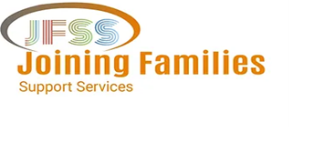

SCHOOL HOLIDAY ACTIVITIES
For NDIS Participants

CLIENT INTAKE FORM

Personal Information
Full Name: D.O.B
Address:
City: State: Postcode:
Phone: Email:

Food Allergies + Dietary Requirements Relevant Medical History

NDIS Reference Number

Next of Kin Information:
Full Name: Relationship:

Phone: Email:

Activities Interested In: (Please choose activities from below)
Day(s):
Date(s):
Time(s):
Activity name(s):

Transport Arrangement:

- Do you want to be picked up and dropped off? YES_________ NO__________________
- Do you have your own transport? YES __________ NO_______________________
- Type of your transport________________________________________________________
- Support needed, please describe; _______________________________________________

APRIL 2023 – SCHOOL HOLIDAY PROGRAM

Week 1: April 11-14

TIME | Tuesday 11th | Wednesday 12th | Thursday 13th | Friday 14th
9AM-12AM | Easter Egg Hunt | Cooking Class  Pictionary | Tie Dye T-shirts | Science Experiment  Charades
1PM-4PM | Leaf Painting | Quiet Reading | Sensory Bin  Colouring In | Scavenger Hunt

Week 2:April 17-21

 | Monday 17th | Tuesday 18th | Wednesday 19th | Thursday 20th | Friday 21st
9AM-12AM | Paper Airplane Competition | Movie | Cooking class | Science Experiment | Jewellery Making
1PM-4PM | - S Clay Pot Art | Face Painting  Colouring In | Painting | Movie | Mother’s day card making

Client’s Full Name Signature Date

Please email this form to: info@joiningfamilies.org
If you have any query regarding this form, please call: 0421 653 673 / 0286053652

